Level # 1
❖ Query 1.1: Find the name and age of all the movie-characters who are not
teenagers.
SELECT Character_Name, Age
FROM movie_characters
WHERE Age IS NOT NULL AND (Age < 13 OR Age > 19);
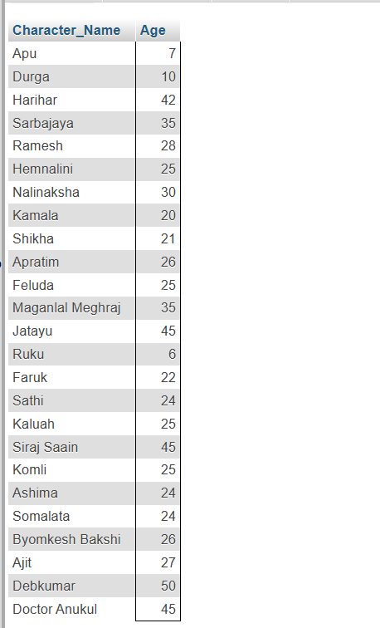

❖ Query 1.2: Find the movie ID of all the movies and the number of
movie-characters in each movie.
SELECT Movie_ID, COUNT(Character_ID) AS Characters
FROM movie_character_relationship
GROUP BY Movie_ID;
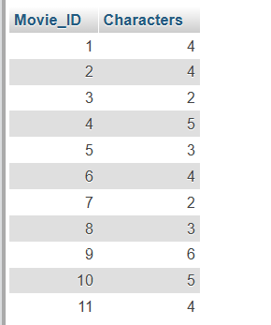
❖ Query 1.3: Find the movie name of all the movies and the number of
movie-characters in each movie.
SELECT M.Movie_ID, M.Movie_Name, COUNT(R.Character_ID) AS Characters
FROM Movie M
JOIN movie_character_relationship R
ON M.Movie_ID = R.Movie_ID
GROUP BY M.Movie_ID, M.Movie_Name;
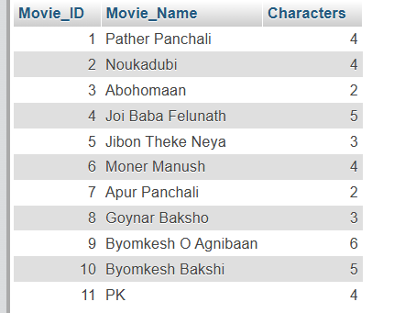
❖ Query 1.4: Find the name, year of release, IMDB rating and the name of the
director of all the movies that contain at most 12 characters (including
spaces) in their name.
SELECT M.Movie_Name, M.Year, M.IMDB_Rating, D.Director_Name
FROM Movie M JOIN Director D
ON M.Director_ID = D.Person_ID
WHERE CHAR_LENGTH(M.Movie_Name) <= 12;
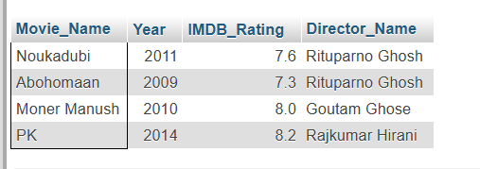
❖ Query 1.5: Display the name and the IMDb rating of the movie with the
highest IMDb rating in each genre.

Level # 2
❖ Query 2.1: Find the name, year of release, IMDB rating of all the movies of
Byomkesh (N.B.: A movie of Byomkesh may not contain the term
‘Byomkesh’ in its name).
❖ Query 2.2: Find the name of all the movies and, the name & the age of the
youngest movie-character in each movie.
❖ Query 2.3: Find the name and age of all the characters from the movies of
Feluda (N.B.: A movie of Feluda may not contain the term ‘Feluda’ in its
name).
❖ Query 2.4: Find the name and age of all the characters from the movies
directed by Satyajit Ray.
➵ 2.4.1: Without Join (using Subqueries) ➵ 2.4.2: With Join
❖ Query 2.5: Find the movie genre with highest average IMDb rating

